**By Ravindu Perera 2014259.**

Data structure stack report

The stack is an abstract data type. Stack examples in real time is a stack of cards or stack of file, one of its feature is that you need to remove from the top as well as add from the top. So it is called as LIFO which means last in first out.

inserting is known as push and removal is known as pop.

Here is a diagrammatic explanation of the process.

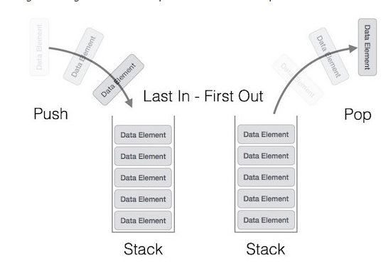

Operations in stack.

* Push
* Pop
* Top (Peek)
* Size
* IsEmpty

Push

Basically it tells adding an object or item, from the top which the only way of adding.

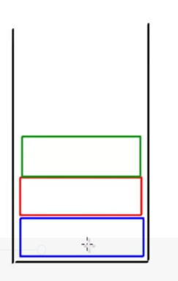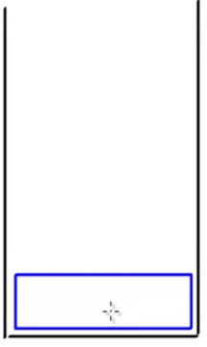

Pop

This means removing and object, from the top which the only way to remove.



The example we can use in our day today life is when browsing the previous and forward pages that we have visited using the history.

**Linked List**

A linked list is a sequence of data structures which are connected to via links.

Linked list contains nodes, the have a head and a tail which will represent the start and the end of the linked list the tail is also pointed to something null to show that it’s the end of the list.

This is a basic representation of the linked list.

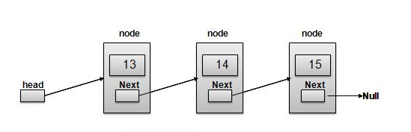

The arrows represent the links between nodes which will link each other.

Comparison of linked list with vectors

The Vector class is similar to a traditional Java array, except that it can grow as necessary to accommodate new elements.

Like an array, elements of a Vector object can be accessed via an index into the vector.

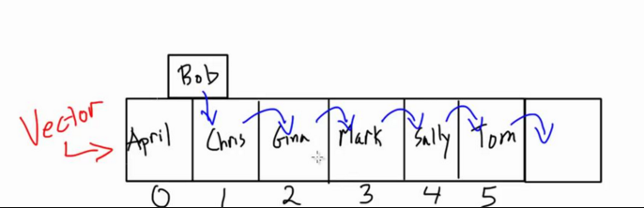

Here you can see that each name is given a specific index no, so if we need to add another contact for example in the diagram above to add bob we have to shift all the other name to the other side which will take time and huge processing power. That’s just for one but if many needs to be added.

This problem is overcome in linked list. in inked list the added named can be straight away pointed by the link and then it will point to the next. Which will reduce processing power and speed. Not only for addition but deletion as well.

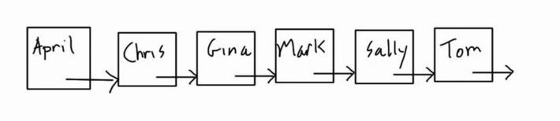

Advantages and Disadvantages of linked list.

* One of the main advantage is that insertion and deletion has a constant time.

Disadvantages

* Random access linear amount of time.

